Match the following to the correct example:
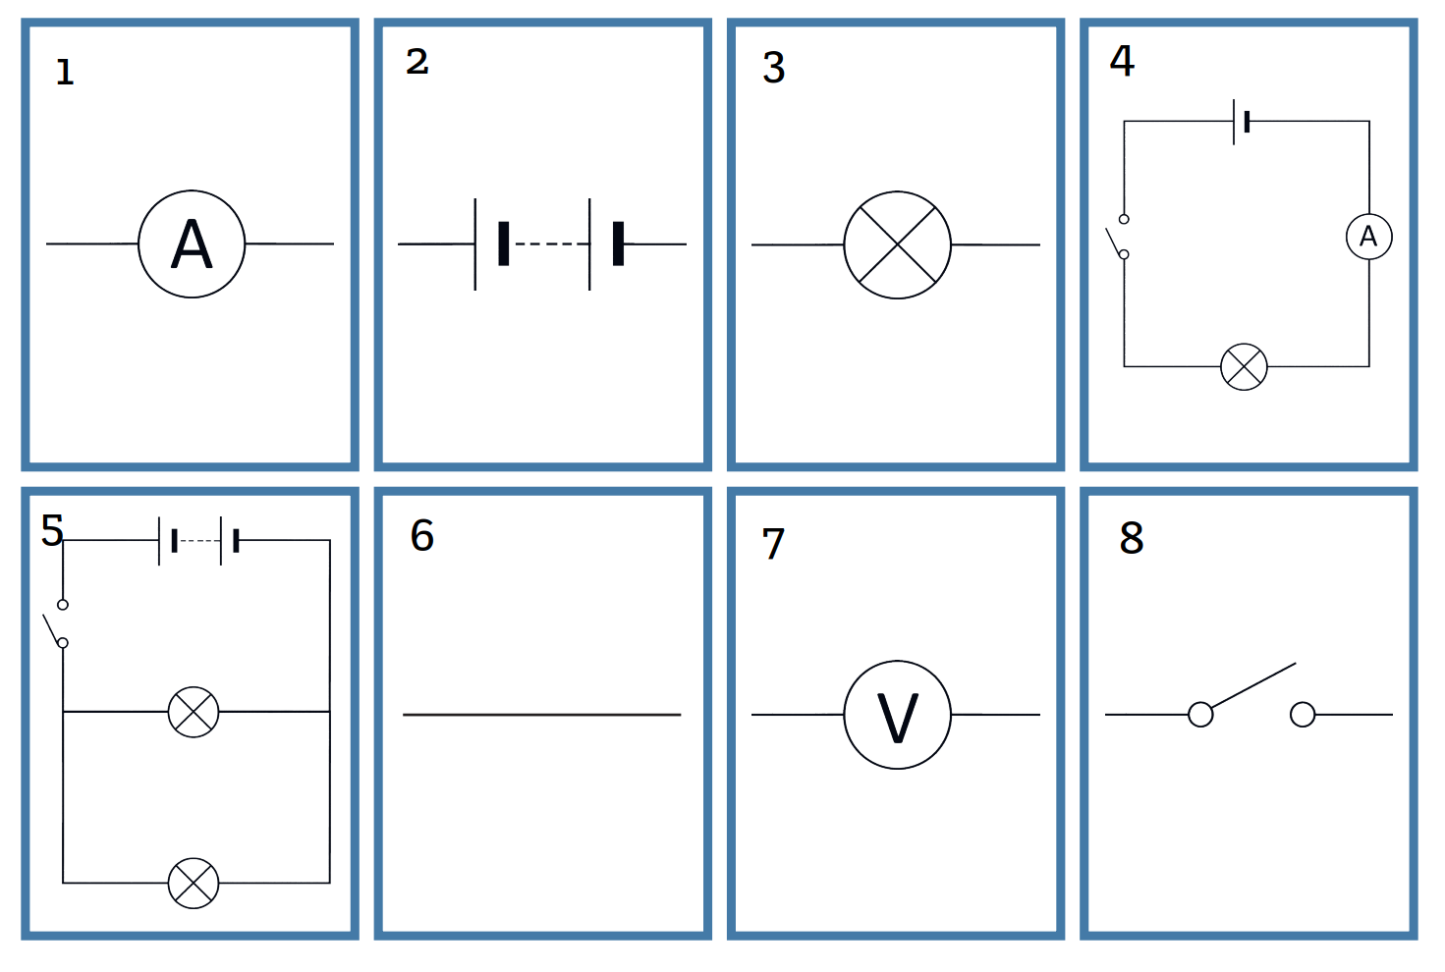
Word Bank: series circuit, GDP, voltmeter, bulb, ammeter, parallel circuit, Iodine, battery, wire, LPG, switch, GPT
1. 1 _________________________
2. 2 _________________________
3. 3 _________________________
4. 4 _________________________
5. 5 _________________________
6. 6 _________________________
7. 7 _________________________
8. 8 _________________________

Match the following to the correct example:
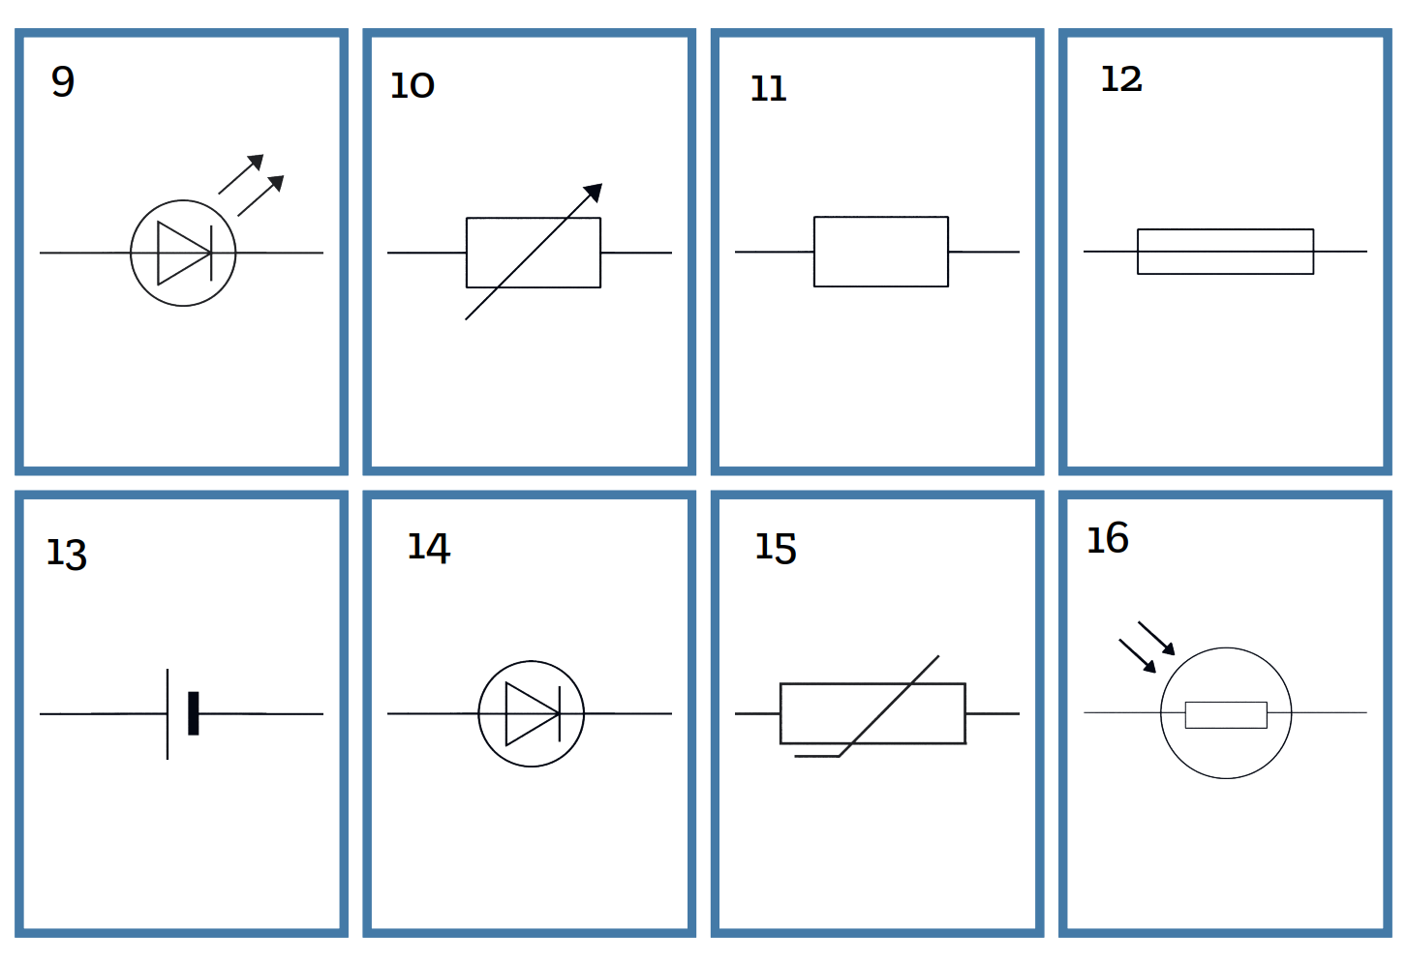
Word Bank: variable resistor, GPT, fixed resistor, thermistor, LPG, fuse, Iodine, diode, cell, GDP, LED, LDR
9. 9 _________________________
10. 10 _________________________
11. 11 _________________________
12. 12 _________________________
13. 13 _________________________
14. 14 _________________________
15. 15 _________________________
16. 16 _________________________

